Project Design Phase-II
Data Flow Diagram & User Stories
Date | 08 October 2026
Team ID | 9100SmartGirls
Project Name | Streamlining IT Procurement: Automating Standard Laptop Orders with Flow Designer
Maximum Marks | 4 Marks

Data Flow Diagrams:
A Data Flow Diagram (DFD) is a traditional visual representation of the information flows within a system. The diagrams below show how order data moves between the requester, the approver, the Request and Requested Item records, the Flow Designer flow, the Catalog Task record and the hardware team.
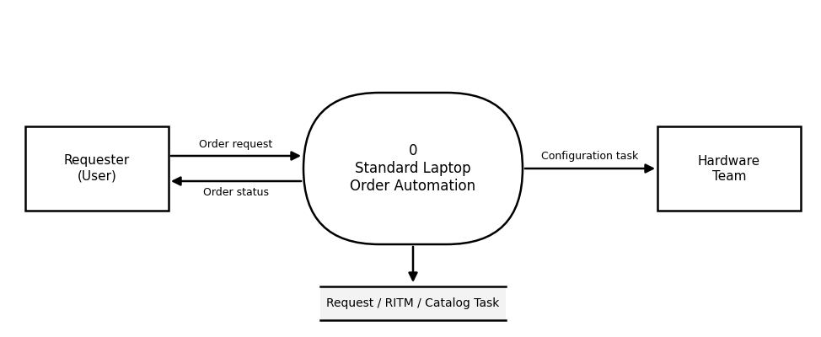
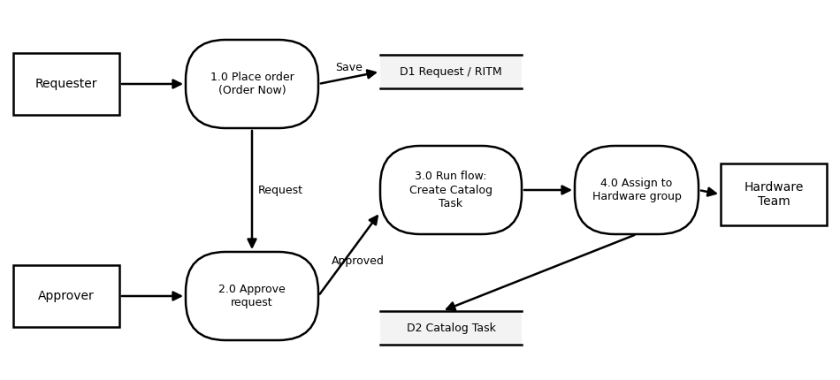
Description: In process 1.0 the requester clicks Order Now on the Standard Laptop item and the Request and Requested Item are stored (D1). In process 2.0 the approver approves the request from the Approvers section. In process 3.0 the Standard Laptop Task flow, triggered by the Service Catalog, runs the Create Catalog Task action and stores the catalog task (D2). In process 4.0 the catalog task is assigned to the Hardware group, and the hardware team configures the laptop.
User Stories
Use the below template to list all the user stories for the product.
User Type | Functional Requirement (Epic) | User Story Number | User Story / Task | Acceptance criteria | Priority | Release
IT Procurement Team Member | Requirement Analysis | USN-1 | As a member of the IT procurement team, I document the business use case and requirements so that the scope of the automation is clear. | Business use case and requirements are documented | High | Sprint-1
Administrator | Flow Creation | USN-2 | As an administrator, I create the flow "Standard Laptop Task" with Application Global and Run As System User. | Flow Standard Laptop Task is created with Application Global and Run As System User | High | Sprint-1
Administrator | Flow Creation | USN-3 | As an administrator, I add the Service Catalog trigger so that the flow starts when a laptop is ordered. | Service Catalog trigger is added to the flow | High | Sprint-1
IT Procurement Team Member | Task Automation | USN-4 | As a member of the IT procurement team, I want the Create Catalog Task action to set the Short Description, Description, Assignment Group (Hardware) and Approval so that the configuration task is created automatically. | Catalog task is created with Short Description, Description, Assignment Group Hardware and Approval Approved | High | Sprint-1
Administrator | Flow Creation | USN-5 | As an administrator, I save and activate the flow so that it runs when the trigger conditions are met. | Flow status is Active | High | Sprint-2
Administrator | Flow Assignment | USN-6 | As an administrator, I attach the flow to the Standard Laptop item through Maintain Items and Process Engine. | Standard Laptop item shows the flow under Process Engine | High | Sprint-2
User | Service Catalog | USN-7 | As a user, I can order a Standard Laptop from the Hardware category of the Service Catalog using Order Now. | Order Now submits the request and the Request Number is shown | High | Sprint-2
Approver | Service Catalog | USN-8 | As an approver, I approve the laptop request from the Approvers section. | Request is approved from the Approvers section | Medium | Sprint-2
Hardware Team Member | Service Catalog | USN-9 | As a member of the hardware team, I receive the configuration catalog task under the Requested Item. | Catalog task is listed under the Requested Item for the Hardware group | High | Sprint-2
Tester | Testing & Validation | USN-10 | As a tester, I execute the functional and performance tests of the flow. | Test cases are executed and results recorded (6 of 7 passed; 1 minor issue open) | High | Sprint-3
Tester | Testing & Validation | USN-11 | As a tester, I run user acceptance testing and track bugs. | UAT test cases and bugs are recorded with severity and status | Medium | Sprint-3
Project Team | Documentation | USN-12 | As a team, we prepare the project documentation and final report and conclude the project. | Project documentation and final report are complete | Medium | Sprint-3

